Directions: The goal of the following problems is to help challenge and deepen your understanding of the current topic. Don’t assume that you will know how to answer every question. You will work with at least two other students in the class to try and find solutions and write arguments for each of the following questions. Be sure that you question your classmates’ reasoning. If you don’t understand how they are getting something, you should ASK THEM TO EXPLAIN! Being able to defend your reasoning is important and so you are actually helping them by asking them to explain.

Challenge Questions
- Consider the graphs of and .
- The x-coordinates for the points of intersection are . Without a graphing utility sketch a picture of the region R determined by these curves and label the intersections points.
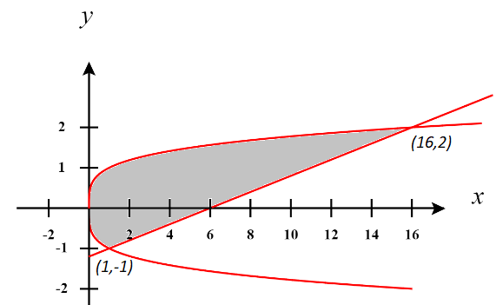

- Determine the area of the region R by integrating with respect to y.

- Determine the area of the region R by integrating with respect to x.
- Create a region (a picture suffices) where when finding the area of the region with respect to x two integrals are required and when working with respect to y three integrals are needed.

Infinitely many answers are possible. Below is a picture of such a region.
You can see that two integrals are required when integrating with respect to x because the function that determines the bottom of the rectangle changes.
You can see that three integrals are required when integrating with respect to y because the functions on the left and right sides of the rectangles keep changing.

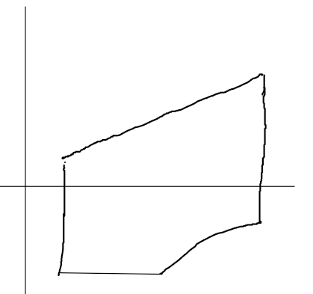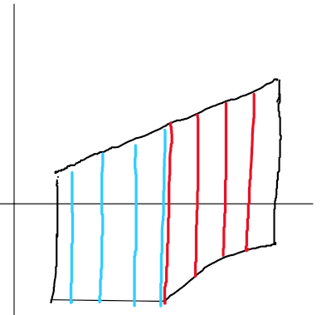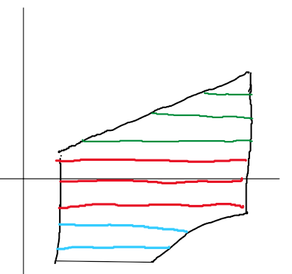

- Consider the region R defined by the curve and the x-axis. There exists a line of the form which will divide the area of this region in half. Determine the value of m.

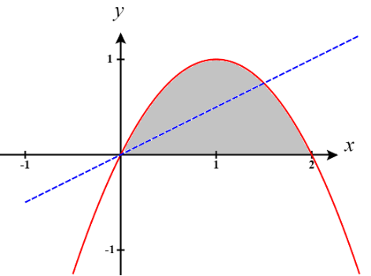
We first draw a picture of the scenario, shown at the right.
We note that the area of R is

We will attempt to find the area under the parabola and above the line. To do this the intersection points of these curves is needed.

The intersections of and are

We then want a value of m such that

Therefore, the equation of the line that we need to divide the given region in half is .

- Suppose that a triangle is formed by the x and y-axis and a tangent line to where .
- Draw a picture of a possible triangle created using the above method.
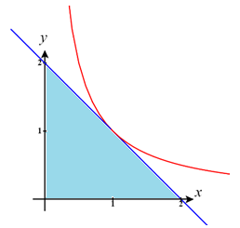

This triangle is formed by drawing the tangent line at which would be given by the equation .

- Show that for any value of the area of the triangle will be constant.

We can see that the area of the triangle above is and so we know that we want to show that the area of any triangle made in this way will also have area 2.

We will create an arbitrary tangent line to and attempt to find the area under it from to its x-intercept.

First, the general equation for a tangent line to when has slope and passes through the point and therefore has the equation:

The x-intercept of this line will always be given by

To find the area of the resulting triangle we will integrate

Therefore, the area of the triangle is always 2.

Note: You could also confirm that the area of the triangle is always 2 by finding the x & y-intercepts of the tangent line and then simply using the area formula for a triangle.

- Let S be the area of the region bounded by the curve and the tangent line to the curve at . If , where a and b are integers and is in simplest form, what is the value of ?

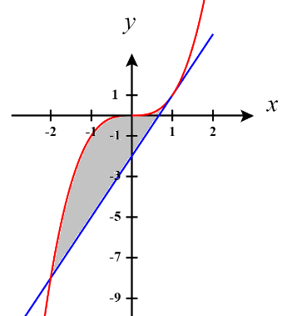
We first find the equation of the line tangent to the curve at . We see that the equation of this line is given by

We note that the intersection between these curves happens at and .

We know that is a solution here and thus is a factor of this polynomial, so we can long divide in order to see how to factor this polynomial.

Therefore

Therefore, the area between these curves is

So, and thus .
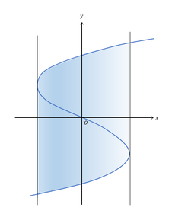
- If the blue curve in the diagram represents the graph and the vertical lines are tangent to the curve, what is the area of the shaded region?

We see that the vertical lines occur when the slope of the tangent lines to are undefined.

We note that
We see that is undefined when .
Therefore, the equations of the vertical lines are .

We will look at each vertical curve one at a time. We first focus on and note that this line intersects the curve at two points, specifically when
We know that one intersection happens at the point of tangency and therefore is a factor. By long division we can establish that
This implies that
Therefore is where the vertical line intersects the curve.
Similarly, we can find that when the vertical line intersects the curve.

Therefore, the area of the shaded region is

OR
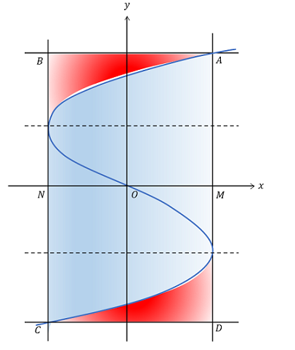
Another way to tackle the question is to notice that the total area in question can be enclosed within the rectangle bounded by the curves , then calculate the area that is not being used within this rectangle and subtract it from the total are of the rectangle. Note that by the symmetry of the curve and rectangle we can simply find

